How to install a Philips Software Patch on a PIIC iX System

i.e. to upgrade from B.02.12 to B.02.15

1. Acquire the latest software update either from the InCentre or a Philips install USB.
2. Copy the two update files (PHILIPS.PIC.PATCH.PIIC_IX_B.02.15.069.EXE and VERSION.XML for example) into the Philips directory on the primary server: “C:\Program Files (x86)\Philips\PIIC iX\B.00\Product\Updates". You will need to delete the existing two files that are already inside the folder. Do not touch the folder named: “Update Files”.
3. Open up the Philips System Configuration application from the Desktop and click “Tools” then “Upgrade” and finally “Software Update”
4. You should see a list of all centrals and servers and also shows their current installed software revision.

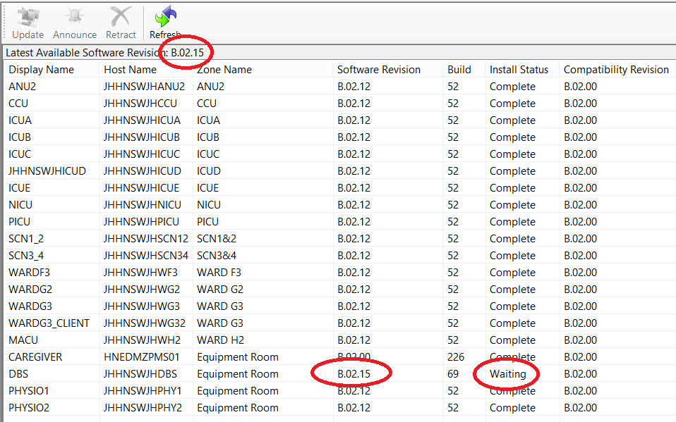

1. At the top of the page the “Latest Available Software Revision” should match the software version of the 2 files you copied into the Philips directory. The Primary Server (labelled DBS) should also show the updated software version and have an install status of waiting.
2. Ensure all centrals and servers are connected to the Primary Server by observing the green rectangles at the bottom of the screen. Right click on the Primary Server and click update. Click Yes/Okay to the warning popup. The update in now being installed on the Primary Server and all connected centrals have now entered into “Service Mode”. The Primary Server might reboot during installation, or maybe just the application might restart.
3. After the Primary Server has been upgraded, go back into the System Configuration and open up the “Software Update”. Verify that the Primary Server has been upgraded to the latest software revision and has a Install Status of Complete.
4. Highlight all of the other centrals and servers and click the Announce button. This action simply pushes the update out to the other centrals/servers. It does not start the installation process. The Install Status should change to waiting when the update has been pushed out.
5. Update the 2 x Physio servers in the same manner as the Primary Server.
6. Update all of the Central stations by going to each central and clicking on the Philips icon in the top let hand corner of the screen, then click Update Now. After the installation, the central should restart into normal monitoring mode.
7. Log back into the Primary Server and open of the System Configuration to view the “Software Update” screen. Verify all centrals/servers are now at the required software revision.